FASHION DEMAND FORECASTING USING MACHINE LEARNING AND DOMAIN ADAPTATION
Scope and Limitations
Department of Computer Science and Engineering, TKR College of Engineering & Technology
Batch A17 (CSE-A) · Academic year [ACADEMIC YEAR]
Table 1: Project team
S.No. | Student name | Roll number
1 | B Shilpa | 23K91A0547
2 | B Hari Narayana | 23K91A0544
3 | A Rani Thejaswini | 23K91A0516
4 | A Sanjana | 23K91A0511

Project guide: Deepthi
Chapter and section numbers quoted in the text (for example Chapter 8 or Section 6.2) refer to the full project report, 17.Final Document. Figures and tables in this document are numbered from 1.

1. SCOPE
The scope follows the six batch objectives and the data that could be obtained. It is stated first as what the product and its measurements cover, then as what they deliberately leave out, so a reader does not mistake an offline experiment for a product feature.

1.1 In scope
• Data: the three H&M tables (transactions, articles, optional customers) uploaded as CSV; a measured subset of 300 articles, 684,392 rows and 107 days, plus a synthetic sample for smoke tests.
• Target: units sold per article per day, forecast one day ahead for evaluation and recursively for 7, 14 or 30 days in the app.
• Models: a seven-day moving-average baseline, XGBoost (default or randomised-search tuned), and an importance-weighted XGBoost for domain adaptation; random forest and LightGBM only as offline comparisons.
• Domains: sales channel, product group and department as the domain-defining column, chosen in the interface.
• Evaluation: RMSE, MAE, safe MAPE and R2 in the app; WAPE, SHAP, inventory units and an unseen-article test offline.
• Product: the FastAPI service, the React console, the original Streamlit app, tests, screenshot and experiment scripts.

1.2 Out of scope
• New-store or new-region transfer (the data hold two sales channels and no geography), promotions, weather, holidays as flags, stock levels, lead times and costs.
• A cold-start mode for products with no history; the forecast route needs at least five days of history and lag features.
• Probabilistic forecasts, direct multi-horizon models, hierarchical reconciliation and deep-learning forecasters.
• Adversarial or correlation-alignment domain adaptation; only importance weighting is implemented.
• Authentication, multiple users, a database, deployment to a cloud service and monitoring: the console is a single-user local tool.
• Computing inventory cost in money or setting reorder points inside the product.
Table 1 sets the scope against the six objectives, separating what the product does, what only the offline harness measures and what was not done.
Table 2: Scope against the batch objectives
Objective | In the product | Offline only | Not done
1 Data and features | Upload, clean, 31 features | - | Promotions, fabric, regional seasonality (not in H&M)
2 XGBoost forecasts | Article level, 7/14/30 days | - | Separate category-level model
3 Domain adaptation | Importance weighting, 3 domain columns | Controls, mean-1 weights | New markets, other methods
4 Adapted vs non-adapted | Before/after report | 6 pairs x 5 seeds, 4 controls | -
5 Explain drivers | Gain importance, optional Gemini text | TreeSHAP | Per-forecast explanation in the app
6 MAE, RMSE, MAPE, inventory | RMSE, MAE, safe MAPE, R2 | WAPE, under/over-stock units | Money-valued inventory impact

2. ASSUMPTIONS
• The 300 best-selling articles of the first transaction shard are representative enough to compare methods; they are the products with enough daily sales for lag features, which also makes them easier than the long tail.
• One transaction row is one unit sold, so the daily count of rows per article is demand; returns and stock-outs are not visible.
• The price and sales channel of the forecast day are known inputs (planned price, expected channel) - the same-day values are used as features.
• A chronological 80/20 split mimics deployment; the last 20 percent of dates (14 December 2018 to 4 January 2019) is a fair, if hard, test period.
• Channel, product group and department are treated as domains; their difference in feature distribution is taken as the covariate shift to adapt to, and the labels are used only to split the rows.
• The H&M files code the sales channels only as 1 and 2; the documents call them channel 1 and channel 2 and do not claim which is the store.
• A single user runs the console on one machine, so one shared in-memory state is sufficient.

3. LIMITATIONS

Data
• Short window. 107 days of one retailer: no earlier year exists in the training window, so yearly seasonality cannot be learned, and the test window holds the Christmas peak and the January sales.
• A selected subset. 300 best-selling articles of one shard (about 0.7 percent of the 42,415 articles sold in it); results for slow movers and new articles are not measured.
• Cleaning understates demand. Dropping exact duplicate rows removed 79,214 of 684,392 rows (11.6 percent), although in this dataset a repeated identical row is usually a real repeat purchase.
• Channel domains are mixtures. The domain label is the channel of most of that day's sales, while demand counts both channels.

Forecasting
• Not better than the simplest rule. Naive lag-1 reaches RMSE 9.22 against 11.09 for XGBoost; the model beats the app's moving average (12.89) but not the naive forecast.
• Absolute-time features hurt. A model using only lag and rolling features scores RMSE 9.40, better than the shipped all-feature model (11.06), because year, quarter and day of year cannot extrapolate beyond the training dates.
• The multi-day forecast degrades fast. WAPE is 41, 77 and 124 percent for days 1-7, 8-14 and 15-30, against 34, 48 and 79 percent for a flat seven-day mean. The loop also leaves week of year, day of year, quarter and month-start flags frozen and holds price and channel at their last values.
• Leaky inputs. The day's own price and channel are features; they are known only if prices and channel mix are planned in advance.

Domain adaptation
• Mostly no gain. As shipped, adaptation improved RMSE on 2 of 6 pairs (range -46.3 to +11.9 percent, mean -14.6).
• The clear gain is not adaptation. Online-to-store improves +11.9 percent, but -2.8 percent when source rows are limited to dates before the target test window; the source model otherwise trains on the future of the target test.
• Weights are not normalised. When the classifier separates the domains perfectly the weights are about 1e-5, XGBoost's min_child_weight of 1 can never be met and the model predicts a constant.
• Weak classifier. Logistic regression on unscaled features does not converge in 1,000 iterations, and unweighted pooling of source and target data beats weighting on 5 of 6 pairs.

Product and evidence
• Explanations. The app shows gain importance, which overstates calendar features; there is no per-forecast attribution, no cold-start mode and no inventory view in the product.
• Single user, in memory. State is lost on restart, and concurrent users would overwrite each other's data.
• External service. AI Insights depends on the Gemini service, which returned 503 or timed out during the screenshot run, so its screen shows the error state.
• Testing. Tests use small synthetic frames; full-size H&M (31.8 million rows), load, accessibility and non-Chrome browsers were not tested.

Hardware, software and process
• One machine. All timings come from one 12-thread desktop processor with other jobs running at the same time, so latencies are indicative; accuracy numbers did not change between runs.
• Library behaviour. The optional LightGBM baseline crashes with an access violation on this machine when pandas or XGBoost are imported before LightGBM; the harness imports it first. The logistic domain classifier prints a convergence warning on every run.
• No peer review of the code. The product was developed and checked by the team and the tests listed in Chapter 7; no independent review or security audit was carried out.

How the limits affect the reading of the results
The data limits mean the model ranking is specific to one winter window: a different window, with a previous year in the training data, could favour XGBoost over naive lag-1. The domain-adaptation limits mean the six-pair result should be read as a test of the shipped procedure, not of importance weighting in general: with mean-1 weights and a time-clean source the average change is close to zero, +0.2 percent, so the honest statement is that no benefit was demonstrated. The product limits mean TrendCast is a study tool for one analyst, not a service.
Two figures show the limitations that matter most for reading the numbers. The first shows what the importance weights look like when the domain classifier separates the two domains perfectly: they fall far below the point where XGBoost can still split a node, so the adapted model collapses. The second shows that the apparent benefit of adaptation depends on the evaluation protocol and on the pair of domains.
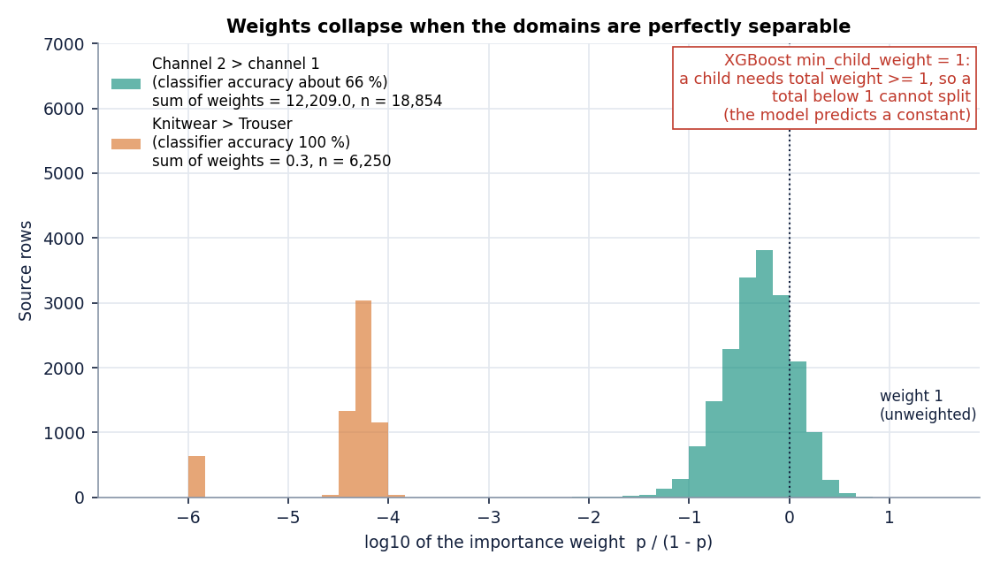
Figure 1: Importance weights for a channel pair and for the Knitwear-to-Trouser department pair.
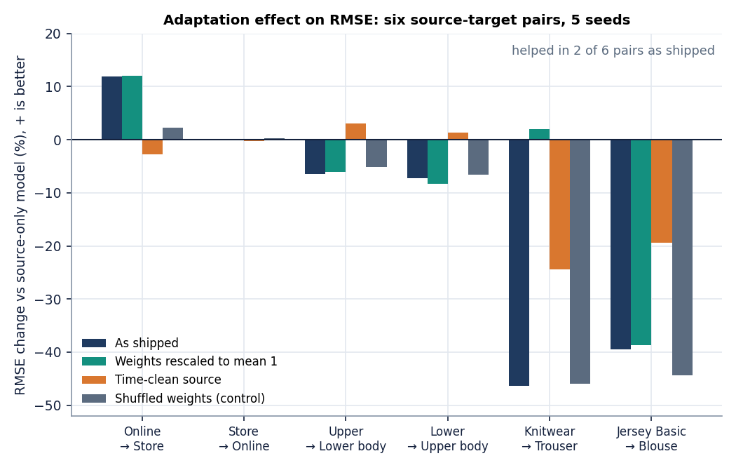
Figure 2: RMSE change from adaptation on six source-target pairs under four settings.

4. WHAT WAS NOT MEASURED
The following were not measured, so no document claims anything about them. Each is either impossible with the 107-day public subset or outside what the product does.
• Multi-year seasonality and a test window outside the Christmas period: the data hold one autumn and winter.
• Transfer to a genuinely new store, region or market; the two sales channels are the only market-like split.
• Promotions, price changes as experiments, weather and holiday effects.
• Inventory cost in money, service levels or reorder points; only under- and over-forecast units were counted, offline.
• Cold start inside the product (the offline attribute-only test is not a product feature).
• User behaviour: no usability study or planner trust test was run.
• Load, concurrency and full-dataset scale of the API.
• The quality and correctness of the Gemini explanations: the service was unavailable when screens were captured.
None of these is hidden in a headline number: the abstract's statements about fewer shortages, less overstock and transfer to new markets are therefore treated as aims, not as results.

